BibTeX:  
@article{article,

author = {Nedel, Luciana and Costa de Souza, Vinicius and Menin, Aline and Sebben, Lucia and Oliveira, Jackson and Maciel, Anderson},

year = {2016},

month = {02},

pages = {1-1},

title = {Using Immersive Virtual Reality to Reduce Work Accidents in Developing Countries},

volume = {36},

booktitle = {IEEE Computer Graphics and Applications}

}

**Bibliography**

Virtual reality (VR) simulators have been used in many training areas, including the ability to perceive dangerous situations. Typical examples are flight, surgery, and driving simulators. In such cases, immersive VEs are created to reproduce the real environments as accurately as possible to impose on the immersed subject the feeling of presence, which in turn elicits behavioral responses that are faithful or at least plausible in relation to the person’s behavior in a real environment.

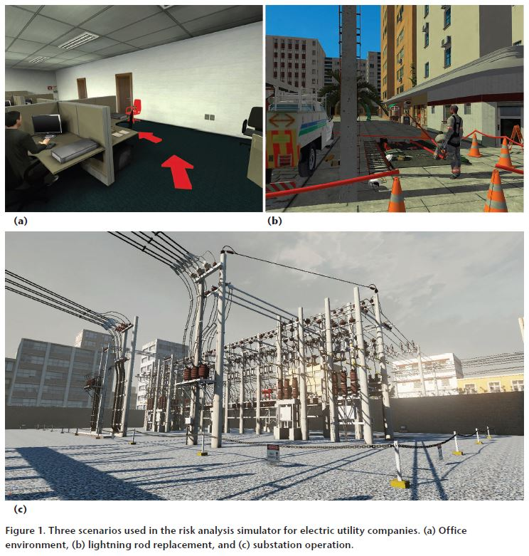

In this paper, we can see the design and use of VR simulators to continuously assess capability for safe behavior among workers. Here, we introduce our framework for risk perception simulation, discuss how we intend to use it to build psychosocial behavior profiles, and share our results from an experimental evaluation we carried out with real users.

VR researchers have already determined that the use of VR can positively affect human sensorial perception. This issue is like the teleoperation of machines and robots, where viewing the environment through cameras and the use of unnatural controllers to accomplish tasks changes the way we perceive and act. These scenarios impose a narrower field of view, different lighting conditions, and variable refresh rates. Strategies used to mitigate these problems are constantly being explored. Some approaches include 3D displays with a wide field of view, data gloves, and other body trackers.

Long-term studies are necessary to assess the effectiveness of the proposed simulators in reducing accidents. In addition to system logs about behavioral groups and user performance. They also recorded video and HR for posterior analysis. Among the collected data, they analyzed the correlation of HR with the feeling of presence. This and other physiological measurements should help to build a framework to evaluate presence more objectively.

**References:**

* [http://ieeexplore.ieee.org.libproxy.uml.edu/](http://ieeexplore.ieee.org.libproxy.uml.edu/document/8038469/citations)
* IEEE Computer Graphics and Applications
* UML Library
* IEEE Webpages

"This is entirely my own work, except as disclosed in the documentation. I gave help to the following persons:   
None  
Signed Kiran C Shettar"